**The first educational forum of the armed forces to be held in Benha University**

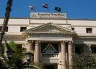

Prof.Dr. EL-Sayed EL-Kady, the university president, inaugurates, on Monday morning, the first educational forum of the armed forces for the first time in the Egyptian universities. This forum is held in Benha University at the presence of colonel / El-Sayed Ghaly, the head of the veterans association, Colonel/ Khalid Mustafa, the leader of defense troops and the several of armed forces officers.