The minister of the higher education heaps praise on the performance of the university hospitals

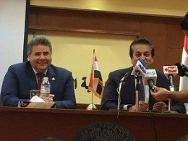
Prof.Dr. EL-Sayed EL-Kady, the university president receives a phone call from prof.Dr. Khalid Abd EL-Gafer, The minister of the higher education and scientific research as he heaps praise on the performance of the university hospitals and thanks all the employees in the university hospitals.

