Six English language curriculums at the faculty of education in Benha University as approved by the supreme council of the universities
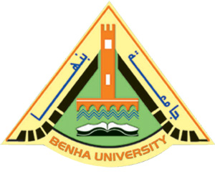
The sector of the faculties of education in the supreme council of the universities approves on the amendments of the bylaw of the faculty of education in Benha University and creating Six English language curriculums. Prof.Dr. Ibrahim Fouda, the dean of the faculty of education says that the new programs are concerned with qualifying the teachers of physics, chemistry, science; math in addition to qualifying the primary teachers specialized in science and math.

