In appreciation of their efforts, Benha University honors the former university presidents

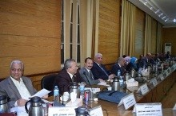
In appreciation of their efforts, Benha University honors the former university presidents since its independence from Zagazig University. The following former university presidents are honored: prof.Dr. Hossam EL-Attar, the first university president of Benha University, prof.Dr. Safwat Zahran, the former university president, prof.Dr. Ali Shams- EL-Din, the former university president in addition to honoring the vice presidents of Benha University as follows: prof.Dr. Shaban Taha, prof.Dr. Soliman Mustafa, prof.Dr. Osama Kamal, prof.Dr. Sohair Saharawi, prof.Dr. Abd EL-Reheim Sholah and prof.Dr. Adel Adawy.

