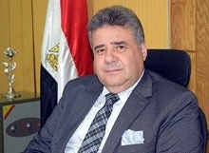
Benha university president receives the strategic plan of the university for 2017-2022

Prof.Dr. EL-Sayed EL-Kady, the university president, in his meeting with the strategic planning team in the university, heaps praise on the team’s performance in preparing the strategic and the executive plans accurately. The team proves to be faithful for the sake of the university’s and Egypt’s progress.

