Benha University is in the Arab Universities conference in Dubai

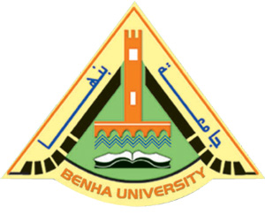
Prof.Dr. EL-Sayed EL-kady, the university president left Cairo, yesterday, to go the united Arab of Emirates and attend the Arab Universities conference in Dubai. This conference discusses the student activities and the student exchange among the Arab Universities in addition to the discussing the difficulties that hinder the student exchanges among the Arab Universities.

.

