An exhibition to market the products of Benha University

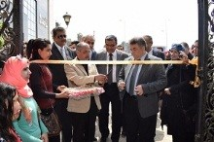
Prof.Dr. El-Sayed El-Kady, the university president announces that there will be a unit to market the products of Benha University electronically in addition to setting up an exhibition to sell and market the products stressing that this is considered an initial step for the small enterprises before graduation.
.

