Honoring the employees in the security section for their devotion at work
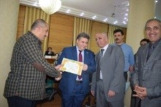
In the university’s leaders council under the presidency of prof.Dr. El-Syed El-Kady, the university president honors Mr. Zein Sarhan, the security director of the university in addition to honoring three others as follows: Muhammad El-Syed Mahmoud, Wael El-Sayed abd EL-Azim and el-Sherif Fekry abdel Wahab.

