Our children is a priority is a ceremony to be held at the faculty of medicine in Benha University

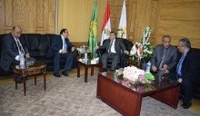
Prof.Dr. El-Sayed EL-Kady, the university president inaugurates the ceremony entitled “Our children is a priority” which is held at the faculty of medicine in Benha University. The ceremony is attended by prof.Dr. Ahmed Sharaway, the governor of the EL-Dakahlia, prof.Dr. Gamal Ismail, the vice president of the community service and the environment development and prof.Dr. Mahmoud abd Sabour, the den of the faculty of medicine.

