A Workshop to be held in the faculty of medicine entitled “Micro-devices between the past and the present”
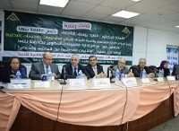
The center of information and research services organizes, in cooperation with the development projects administration under the presidency of prof.Dr. Muhammad El-Sayed, a Workshop entitled “Micro-devices between the past and the present”. This workshop is held under the auspices of prof.Dr. El-Sayed El-kady, the university president and it is attended by prof.Dr. Mervit Saad, the professor of the histology in the faculty of medicine, prof.Dr. Margret zilmer, the professor in the university of Düsseldorf and prof.Dr. Ibrahim Rageh, the deputy of the faculty of medicine.

