Benha university president hosts the head of the Libyan student union and the Egyptian- Libyan tribe’s coordinator
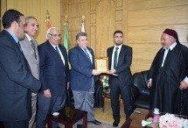
Prof.Dr. EL-Sayed EL-Kady, the university president stresses that the Egyptian people stands by the Libyan people in their war against terrorism wishing prosperity for the Libyan people. This statement concurs with his meeting Asel Saied el-giwfy, the head of the Libyan student union and sheikh/ Adel el-faddy, the Egyptian- Libyan tribe’s coordinator. This meeting is attended prof.Dr. Nofal el-geaedy, the head of public relationship of the Libyan students, prof.Dr. EL-Sayed el-Fayoumy and Mr. Wahid Khalawy, the secretary of the university.

