The former minister of higher education thanks Benha University for holding the Egyptian education forum

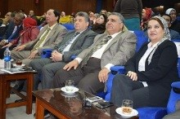
Prof.Dr. Muhammad El-Nashar, The former minister of higher education thanks Benha University for holding the Egyptian education forum. This statement concurs with his presence the concluding ceremony of the education forum in which the recommendations were drawn, a musical performance was held, the participants were awarded. The former minister urges the supreme council of the universities to hold this forum annually.

