The university president looks closely at the workshops of the education forum

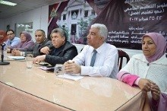
Prof.Dr. El-Sayed EL-kady, the university president asserts that the majority opinion should be respected even it doesn’t accord with personal opinion. This statement concurs with the university president’ constant participation in the workshop of the faculties’ members, the teaching assistants and the stduents in order to hold the first education forum form 22-2-2017 to 25-2-2017 and draw important and comprehensive recommendation to refer them to the minister of higher education.

