Benha University’s leaders Council Honors the Winning Students in the Young Researchers Conference
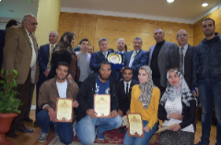
Benha University leader’s council honors the winning students in the sixth young researcher’s conference which is held in Aswan University from 5-2-2017 to 7-2-2017. It is important to say that Benha University participates with seven researches in the fields of medicine, science, engineering, agricultural, computer and informatics. The students who participate in the conference are as following; student/ Ahmed Yasser from the faculty of science, student/ Amany Muhammad from the faculty of education, the students / Mona Red and Ayman Gamil from the faculty of agriculture, the students/ Yasser Mahmoud and Muhammad Ahmed from the faculty of engineering and student / nourhan Muhammad from the faculty of applied arts.

