In a response to the university president’s initiative 1.6 tons of Cleaners to be sent to “Arab- El-Atiat” village in Assiout

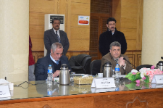
The leaders’ council, headed by prof.Dr. EL-Syed El-Kady, the university president approves on the bulletin of the faculty of science council regarding 1.6 tons of cleaners which will be donated for the comprehensive convoy. This convoy will be sent to “Arab- El-Atiat” village in Assiout and it lasts from Friday 17-2-2017 to Sunday, 19-2-2017. This convoy is in the frame of the initiatives of prof.Dr. EL-Syed El-Kady, the university president to serve the community. The convoy is organized in cooperation with Mr. Yasser Desoky, the Governor of Assiout and prof.Dr. Ahmed abdo, the president of Assiout University.

