For the First Time in the Faculty of Education, Six English-Language Curriculums

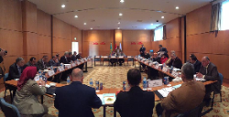
Benha university council holds its meeting in Sharm EL-Sheikh approves on the bulletin of the faculty of education to launch six curriculums to prepare teachers of English, physics, chemistry, science and math in addition to preparing the teachers of primary education in science and math. The bylaws of these programs should be ready to be delivered to the sector committees of supreme council of the universities to be endorsed. Prof.Dr. EL-Sayed El-Kady, the university president says that these programs meet the demands of the labor market on one hand and develop the quality of education in the university’s faculties on the other.

