New English language Programs to meet the Demands of the EL-Nile International Schools

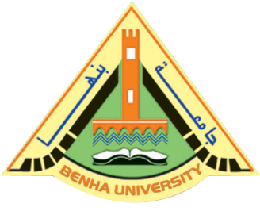
Prof.Dr. El-Sayed El-Kady, the university president assigns prof.Dr. Ibrahim Fouda, the dean of the faculty of education to urgently prepare the teachers of the new English language programs of physics, chemistry, biology, math to achieve the strategic plan of the state in meeting the demands of the international and private schools which are in need of highly-skilled teachers.

