The Community Service Council of Benha University discusses the Problem of the Industrial Companies and Gives a Priority to Small Enterprises in building the National Economy

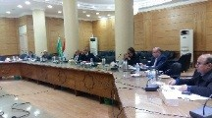
The community service council of Benha University discusses, in its meeting under the presidency of the prof.Dr. Gamal Ismail, the vice president of community service and environment development and in the presence of the faculties’ deputies of environment affairs, the report of the faculties of agriculture and veterinary medicine that is about the rabbits feeds and the economic nutrition of young breeders and production of the quail in the Egyptian village to increase the production of the meat and eggs. Prof.Dr. Gamal Ismail, the vice president of community service and environment development asserts that small and medium enterprises are important in building the national economy and providing the youth with job opportunities. The vice president adds that the council discusses the preparations of holding a workshop entitled “the industrial problems that face the industrial cities in El-Qulubia” under the auspices of Prof.Dr. El-Sayed El-Kady.

