The University President inspects the Exams in the Faculty of Science

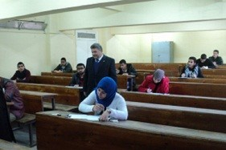
Prof.Dr. El-Sayed El-Kady, the university president inspects that the exams are up and running in the faculty of science. The university president is accompanied by prof.Dr. Abd-Azim Mehna, the faculty dean and makes sure that exams are nicely-up and running and the rules set forth by the university council are strictly followed.

