Seeking out Solutions of the Education Problems in Benha University Talk Week

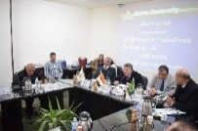
The university leader council discussed, in its weekly session on Tuesday noon under the presidency of the prof.Dr. El-Sayed EL-Kady, the university president, the preparations that supposed to be ready to hold the talk week which will be held from 25-2-2017 to 28-2-2017. The meeting was held in the presence of prof.Dr. Gamal Ismail, the vice president of the community service and environment development, prof.Dr. Hesham Abu El-Enin, the vice president of post-graduate studies and scientific research, the faculties’ deans and the university president chancellors. This talk week aims at suggesting a comprehensive vision to find solutions of higher education and scientific research in Egypt.

