The university President discusses the Results of his Visit to China: 12 Research projects with the faculties of Agriculture and Veterinary Medicine and 100 Scholarships with 5 Chinese Universities

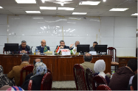
For the first time in Benha university, prof.Dr. El-Sayed El-Kady, the university president meets with 300 teaching assistants and an assistant lecturer form the different faculties in the university and discusses the results of his visit to China with an official delegation of the university included; prof.Dr. Muhammad Abu-Salim, the dean of veterinary medicine faculty, prof.Dr. Mahmoud Eraqi, the dean of agriculture faculty, prof.Dr. Tamer Samir, the acting dean of the faculty of applied arts and prof.Dr. Osama Ezat, the professor of the faculty of engineering/Shubra.

