The University President inaugurates the Exhibition of the Stduents of the Faculty of Specific Education
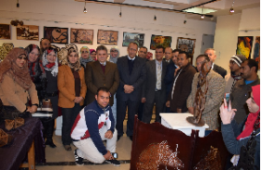
Prof.Dr. El-Sayed El-Kady, the university president inaugaruted, on Tuesday morning, the exhibition of the stduents of the faculty of specific education. The university president was accompanied by prof.Dr. Ramadan Muhammad, the faculty’s dean who explains what the exhibition included off.

