A Professor from Rome University visit the University to increase the Mutual Researches in the Field of Geology of Mining

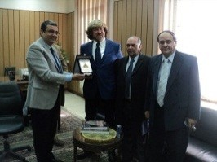
Prof.Dr. Hesham Abu El-Enin, the vice president of post-graduate studies and research hosts prof.Dr. Dario Dilafollow, the professor at the University of Rome in Italy in the frame of mutual cooperation, visits and students exchange to study the characteristics of rocks that are used in the ancient pharaonic or byzantine civilizations. The vice president states that the university seeks to get the European fund by presenting research projects in the field of Geology and applied arts. Prof. Dilafollow visits the faculty of science to deliver a lecture for the students of the Geology department.

