At the End of the Faculties’ League in Benha University: Sport Festival and Awards

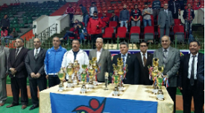
Prof. Dr. El-Sayed EL-Kady, the university president honors the winners in the league of games which was organized in the youth care general administration under the supervision of prof. Dr. Moshbeh EL-khily. The ceremony was attended by prof. Dr. Gamal Ismail, the vice president of community service and environment development, the faculties’ deans and faculties’ members. The university president asserts that the university pays a great attention to the student activities, supports the ideas of the youth and encourages the fruitful student initiatives. The university president urges the students to practices sport to be healthy and capable of serving their country. Prof. Dr. Khalid Esawi, the general coordinator of student activities announces the final results of the faculties’ league in the university.

.

