Signing a cooperation protocol between Benha University and El-Hashamia University

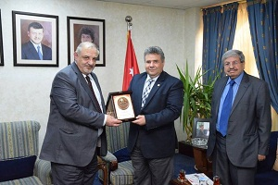
In the Arab universities meetings, prof. Dr. El-Sayed El-Kady visits El-Hashamia University and meets its university president Kamal El-Din Bani Hani. They discuss the possibility of the mutual cooperation in the different realms in addition to signing a cooperation protocol between the two universities. The Jordanian side expresses his desire to cooperate with Benha University and prof. Dr. El-Sayed El-Kady invites the El-Hashamia University.

.

