5.6 million L.E to fund (56) research group in Benha University

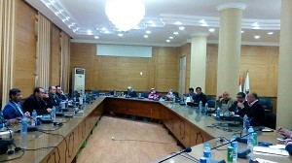
The scientific research fund board, headed by prof. Dr. Hesham Abu el-Enin, the vice president of post-graduate studies and research, approves in its last meeting to provide fund for (56) research groups and the young researchers by an amount of 5.6 million L.E. prof. Dr. Hesham Abu el-Enin stresses that the board customizes 100,000 L.E. for the young researchers. The statement concurs with the vice president of post-graduate studies and research’s meeting with the young researcher in Benha University. He also asserts that the funded research projects should have a positive impact on the university. This meeting was attended by prof. Dr. Maher Hasb-EL-Nabi, the university president chancellor of scientific research and prof.Dr. Alaa Amin, the general manager of projects administration and prof. Dr. Naser El-Gizawy, the faculty of agriculture’s deputy of post-graduate studies and research

.

