Benha University is in the Arab universities meetings

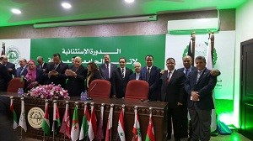
In Jordan, the proceedings of the two-day Arab universities meetings. Many universities participate in this event including Benha University and prof. Dr. El-Sayed El-Kady represents Benha University in the proceedings of this forum. Prof. Dr. El-Sayed El-Kady, the university president states that this forum is important because it discusses many topics that help to create a frame for an effective Arab cooperation to improve the educational process. Prof. Dr. El-Sayed El-Kady says that he will visit the university of EL-Zaytona and El-Hashamia University for future cooperation between Benha University and its peers in Jordan. Finally, Prof. Dr. El-Sayed El-Kady expects that the visit’s results will be fruitful regarding the students and the educational process in three universities.

.

