A Monthly Forum to be held at Dermatology and Andrology Department in Benha entitled «A Boom in Plastic Surgeries and Laser»
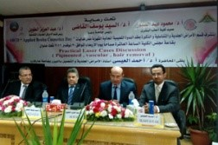
The faculty of medicine holds a monthly educational forum at Dermatology and Andrology Department in Benha University. The forum is attended by prof. Dr. Ahmed EL-Eisa, the professor of Dermatology and Andrology at the University of Harvard, prof. Dr. Mahmoud Abd-El-Sabour, the faculty's dean, prof. Dr. Abd-El-Aziz El-wail, the head of the department and the several professors and students of the faculty. Prof. Dr. Ahmed EL-Eisa speaks of how important this forum is for all those interested in the field and how such forums reinforces the relationship between the professors in the Arab world. Prof. Dr. El-Sayed El-Kady, The university president asserts that people appreciate and love doctors and there is a heyday in the Dermatology and Andrology field. The university president stresses that Egypt has strong relationships with the Arab countries and salutes prof. Dr. Ahmed EL-Eisa and the kingdom Saudi Arabia. At the end of forum, the university president says that students, staff members and employees are united to serve the country.

.

