The List of the International Scientific Magazine Accredited by Scimago

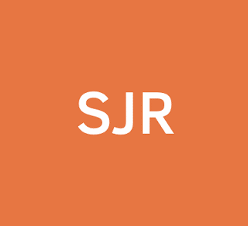
There is a new service of the staff members and researchers in Benha University which enables them to know the list of the international scientific magazine accredited by Scimago to avoid publishing in the false magazines. To choose the appropriate magazine in any field, kindly have a look on the following link;
http://bu.edu.eg/e-services/Scimago_J_R.php

.

