A Big Warring against Smoking in Benha University
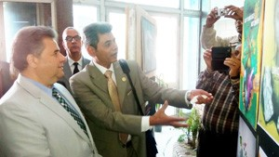
Prof. Dr. El-Sayed EL-Kady, the university president inaugurates the exhibition of artistic production of the students of the faculty of fine arts entitled “A big warning against smoking”. This exhibition was organized at the faculty of medicine in cooperation with the faculty of fine arts. It was attended by prof.Dr. Mahmoud Abd EL-Sabour, the dean of the faculty of medicine, prof.Dr. Ibrahim Rageh, the faculty’s deputy of community service and environment development, prof.Dr. Shawky EL-Desoky, the fine arts faculty’s deputy of community service and environment development and the general / Talat Mousa, the chancellor of Nasr Military Academy. The exhibition’s inauguration is held in the frame of the forum of the societal participation about the role of the armed forces in Egypt development.

