The university president to the youth: we work for all of you

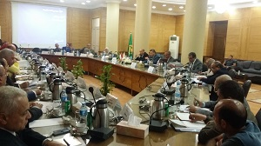
Prof. Dr. el-Sayed EL-Kady, the university president delivers a message to the youth and the university students in which he says: "we work for all of you and you have to work hard to be do good to your country". This statement was uttered in university council headed by the university president. The meeting was held in the presence of prof. Dr. Adel Adawy, the former minister of healthcare, prof. Dr. Hesham Abu EL-Enin, the vice president of post –graduate studies and research, prof. Dr. Gamal Ismail, the vice president of community services and the environment development, the faculty deans and the university president advisors and student activities representatives.

