The university president surprises the university hostel in Shubra to inspect restaurants and meet students

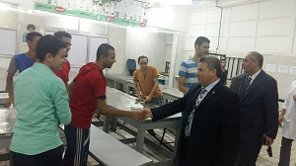
Prof. Dr. El-Sayed EL- kady, the university president asserts that the university is keen on providing the best services to the students in the university hostels. He stresses that the university seeks to contact students to solve their problems. This statement concurs with the university president’s visit to the university hostel in Shubra with Amin Khalawy to make sure in the hostel regarding kitchens, restaurants, is well-done. The university president meets the students to listen to their opinion in the hostel-related issues. He ordered that students’ problems should be solved.

