The university president cancels the celebrations to mourn the army martyrs

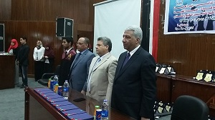
The University president Prof. Dr. El-Sayed EL-Kady ordered all the university leaders and the faculties’ deans to cancel the celebrations in the faculties to mourn the army martyrs who were assassinated by the terrorists in Sinai. He says that the faculties should abide by the official protocol.

