Benha university delegation participates in a ceremony to honor the top students in Jordon

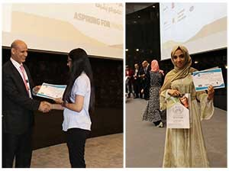
Benha university delegation participates in the international fair of education in the middle- East and north Africa. This fair was held at King Hussein city in Jordon to honor the top students there. Prof. Dr. Mahmoud Eraqi , the dean of the faculty of agriculture as a representative of the delegation which honors the top students. The delegation was headed by prof. Dr. Mahmoud Eraqi, the dean of the faculty of agriculture , prof. Dr. Hesham El-batsh, the deputy of the faculty of engineering in benha for post-graduate students and research and prof. Dr. Muhammad Basiony, the deputy of the faculty of commerce for education and students affairs.

.

