Prof. Dr. El Sayed Yusuf El Kady inspects Faculty of Engineering at Shoubra

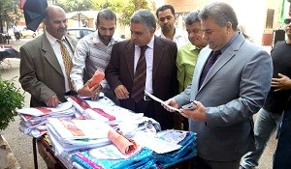
Prof. Dr. El Sayed Yusuf El Kady, the President of Benha University inspected study halls at Faculty of Engineering at Shoubra in 27\9\2016. The University President congratulated students on occasion of the new academic year 2016\2017 and encouraged them to do their best to achieve their goals.

