Prof. Dr. El Sayed Yusuf El Qady Congratulates the University on the Occasion of Eid Ul-Adha

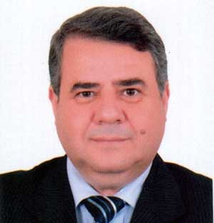
Prof. Dr. El Sayed Yusuf El Kady, the President of Benha University congratulates faculty members, employees, and students on the occasion of Eid Ul-Adha …. May the Blessings of Allah Fill our Life and our beloved Egypt with Peace, Joy and Prosperity.

