Benha University organizes KAB Program 2016

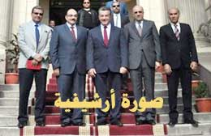
Prof. Dr. Gamal Ismail, Benha University Vice-president for Community Service and Environment Development Affairs said that (Know About Business ) Program “KAB” which organized by the University and the International Labour Organization “ILO” will be held in the duration from Sunday, 14/08/2016 to Thursday, 25/08/2016 at the Halls of the Campus.

