Video Conference Meeting of NELC postponed to August03, 2016

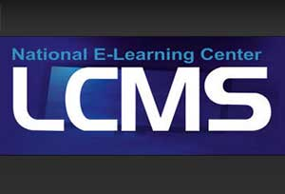
The National E-Learning Center (NELC) has postponed the meeting via video conference with Benha University to Wednesday, August03, 2016, 10:00am to 1:00pm which will be held for introducing new programs for the theoretical e-courses production.

