Cooperation between Benha University and the Iraqi Consul

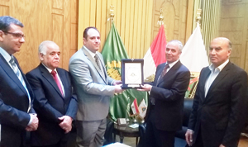
Prof. Dr. Gamal Ismail, Benha University Vice-president for Community Service and Environment Development Affairs and Prof. Dr. Soliman Mustafa, the University Vice-president for Education and Students’ Affairs have met Mr. Zain Abbas, the Iraqi Consul in Cairo by the attendance of the deans of the faculties of arts and law to enhance the cooperation ways between the Egyptian Higher Education and the Iraqi Embassy in Cairo as well as encourage the Iraqi students to study in Benha University.

