Prof. Dr. Maher Khalil gets the State Merit Award in Agriculture 2015

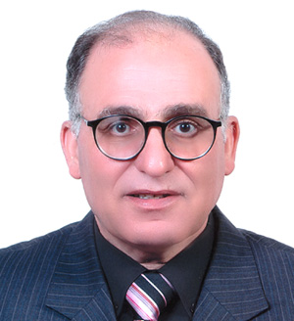
Benha University congratulates Prof. Dr. Maher Hasab El Naby Khali, the supervisor of the University Scientific Researches Fund and the Advisor to the University President for the Scientific Research for getting the State Merit Award in the agriculture science field 2015.

