Cooperation between EHZC and Benha University

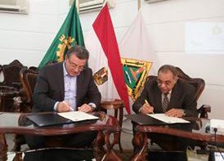
Dr. Safwat El Nahas, the Secretary General of the Egyptian House of Zakat and Charity “EHZC” and Dr. Ali Shams El Din, the President of Benha University have signed a cooperation agreement to treat the poor patients and zakat beneficiaries in Benha University Hospital by the attendance of the University Vice-presidents and members of the People's Assembly.

