SCU Delegation discusses Higher Education Internationalization in South Africa

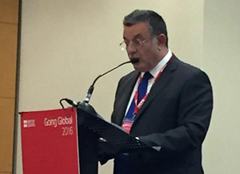
The International Conference of Higher Education held in Cape Town, South Africa has been launched with participation of more than 800 universities and education institutions from 90 countries.
It is worth mentioning that Egypt has been represented by the Secretary General of the Supreme Council of Universities “SCU” in addition to Benha and Alexandria Universities.

